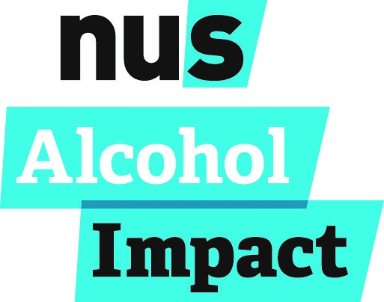
Intervention template

Detailed intervention template which can be submitted as evidence for IN032

First worked behaviour:

What precisely is the behaviour you are aiming to change?
For example: reducing damage in communal spaces of halls after nights out

Is this an existing intervention? A revision to an existing intervention? Or a new idea?

Are plans already under way for this intervention? Yes or No?

Who is your target audience?
Hints & Tips: Are you aiming the intervention at first year students? Sports club members? International students?

Where and when will the intervention take place?
Hints & tips: Will this happen at an event such as welcome week/s? Will this be an ongoing campaign?

How many students do you hope to reach: expected number?

Method of intervention
Hints & Tips: How will you carry this out? What does the intervention look like?

Who will help you to deliver this project?
Hints & Tips: who will be involved; students, sabs, university partners, community agents, retailers?

Level of resource/resource needs
Hints & Tips: how much will this cost you? Any specific materials or equipment you will need?

Which context are you covering Individual, Social or Material? And which factors are you covering?
For example; if working on specific behaviours relating to binge drinking, you may identify the provision of safe transport (infrastructure), or information to tell people how small a minority student binge drinkers are (norms).

How do you plan to evaluate the intervention?
For example: counting numbers of students attending, asking for feedback from students, questionnaires

If you had additional resources in the future, how do you feel you could extend this evaluation?

What does success look like?
For example: What changes in behaviour do you expect to see? How would the factors in the ISM model change? Do these changes lead on to anything else?

Second worked behaviour:

What precisely is the behaviour you are aiming to change?
For example: reducing damage in communal spaces of halls after nights out

Is this an existing intervention? A revision to an existing intervention? Or a new idea?

Are plans already under way for this intervention? Yes or No?

Who is your target audience?
Hints & Tips: Are you aiming the intervention at first year students? Sports club members? International students?

Where and when will the intervention take place?
Hints & tips: Will this happen at an event such as welcome week/s? Will this be an ongoing campaign?

How many students do you hope to reach: expected number?

Method of intervention
Hints & Tips: How will you carry this out? What does the intervention look like?

Who will help you to deliver this project?
Hints & Tips: who will be involved; students, sabs, university partners, community agents, retailers?

Level of resource/resource needs
Hints & Tips: how much will this cost you? Any specific materials or equipment you will need?

Which context are you covering Individual, Social or Material? And which factors are you covering?
For example; if working on specific behaviours relating to binge drinking, you may identify the provision of safe transport (infrastructure), or information to tell people how small a minority student binge drinkers are (norms).

How do you plan to evaluate the intervention?
For example: counting numbers of students attending, asking for feedback from students, questionnaires

If you had additional resources in the future, how do you feel you could extend this evaluation?

What does success look like?
For example: What changes in behaviour do you expect to see? How would the factors in the ISM model change? Do these changes lead on to anything else?

